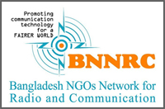
Two Days Training Workshop
Amateur Radio Operation
on the eve of
Bangladesh Amateur Radio Service Examination 2017

COAST / BNNRC Meeting Room, 17 -18 August, 2017

Organized by:
FAIRS Bangladesh
COAST Trust
Bangladesh NGOs Network for Radio and Communication

Supported by:
COAST Trust, Dwip Unnayan Sangtha, Udayan Bangladesh

